Tangential Cross Section

Definition
# Source: AI Source: Provided by: [Data Path: Persons Table -> ID Column: 1, Name_En Column: Motasem Essam] -> From: [ChatGPT] on [7/25/2026]
A Tangential Cross Section is the intersection between a solid and a plane that touches the solid at a boundary point or along a boundary line without passing through its interior.
Unlike an ordinary cross section, which usually produces a two-dimensional region, a tangential intersection may produce a single point, a line segment, or a curve, depending on the solid and the contact.
A tangent plane to a sphere, for example, touches the sphere at exactly one point. Therefore, its intersection has no two-dimensional area.

Geometric Representation
# Source: AI Source: Provided by: [Data Path: Persons Table -> ID Column: 1, Name_En Column: Motasem Essam] -> From: [ChatGPT] on [7/25/2026]
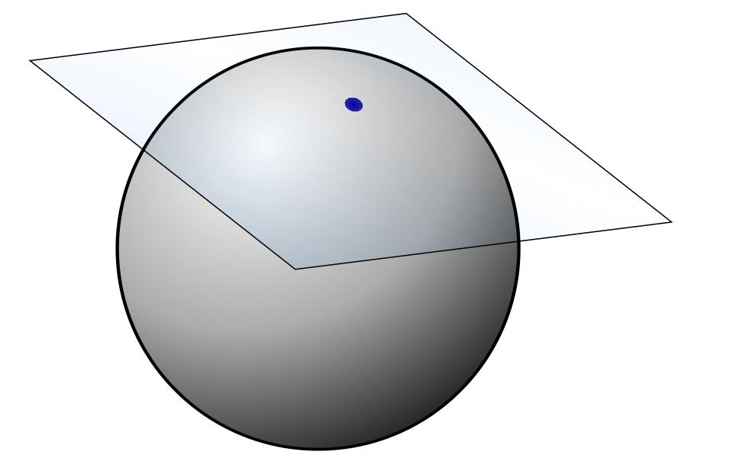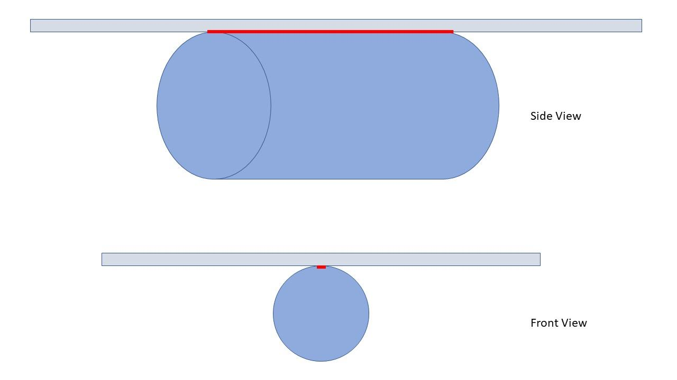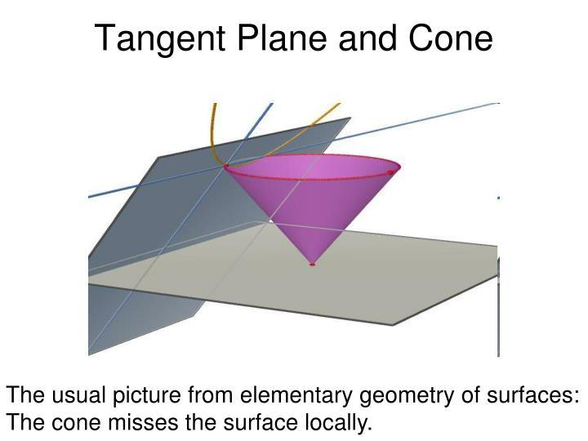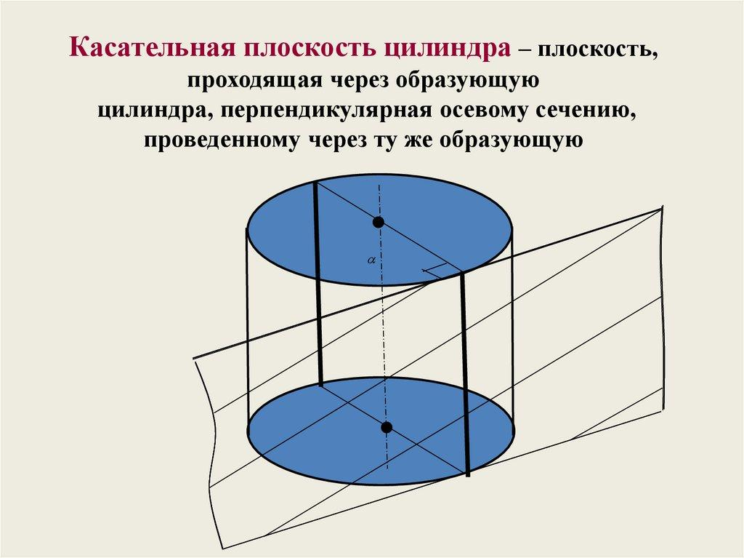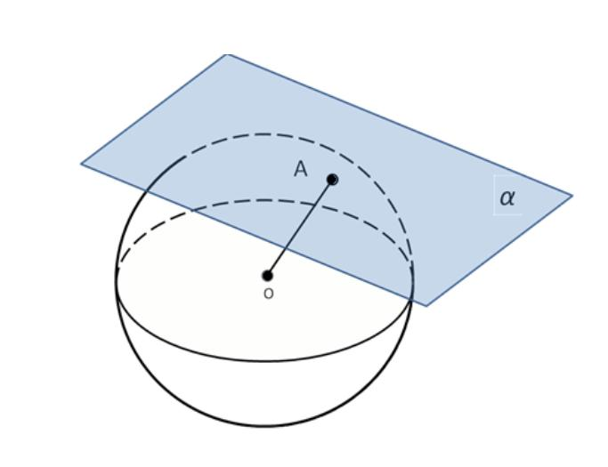

Geometric Structure
# Source: AI Source: Provided by: [Data Path: Persons Table -> ID Column: 1, Name_En Column: Motasem Essam] -> From: [ChatGPT] on [7/25/2026]
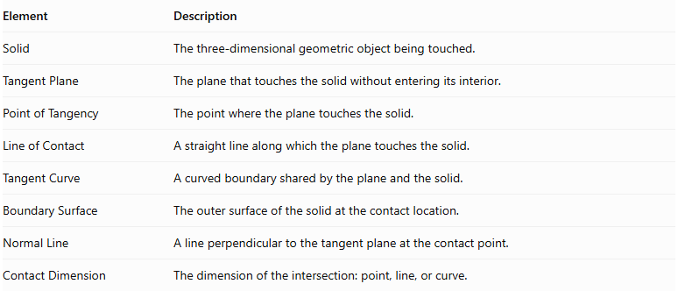
Element | Description
Solid | The three-dimensional geometric object being touched.
Tangent Plane | The plane that touches the solid without entering its interior.
Point of Tangency | The point where the plane touches the solid.
Line of Contact | A straight line along which the plane touches the solid.
Tangent Curve | A curved boundary shared by the plane and the solid.
Boundary Surface | The outer surface of the solid at the contact location.
Normal Line | A line perpendicular to the tangent plane at the contact point.
Contact Dimension | The dimension of the intersection: point, line, or curve.

Main Characteristics
# Source: AI Source: Provided by: [Data Path: Persons Table -> ID Column: 1, Name_En Column: Motasem Essam] -> From: [ChatGPT] on [7/25/2026]
- The plane touches the boundary of the solid.
- The plane does not pass through the solid's interior.
- The intersection may have zero area.
- The contact may occur at one point or along a line or curve.
- The contact geometry depends on the shape of the solid.
- For a smooth surface, the tangent plane is determined by the local orientation of the surface at the contact point.

Types of Tangential Intersections

Point Tangential Intersection
# Source: AI Source: Provided by: [Data Path: Persons Table -> ID Column: 1, Name_En Column: Motasem Essam] -> From: [ChatGPT] on [7/25/2026]
A plane touches a solid at exactly one point.
Example: Tangent Plane to a Sphere
- The plane touches the sphere at one point.
- The radius drawn to the point of tangency is perpendicular to the tangent plane.
- The intersection consists of a single point.

Line Tangential Intersection
# Source: AI Source: Provided by: [Data Path: Persons Table -> ID Column: 1, Name_En Column: Motasem Essam] -> From: [ChatGPT] on [7/25/2026]
A plane touches a solid along a straight line.
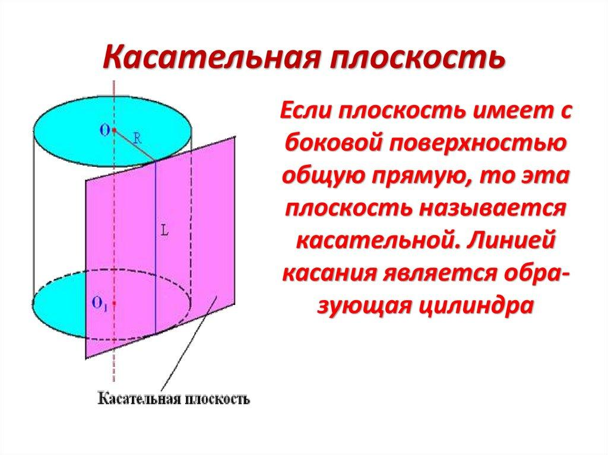
Example: Tangent Plane to a Cylinder
- The plane touches the cylindrical surface along one straight generator.
- The intersection is a straight line segment for a finite cylinder.
- The line of contact is parallel to the cylinder's axis.

Curved Tangential Intersection
# Source: AI Source: Provided by: [Data Path: Persons Table -> ID Column: 1, Name_En Column: Motasem Essam] -> From: [ChatGPT] on [7/25/2026]
A plane touches a solid along a curved boundary.
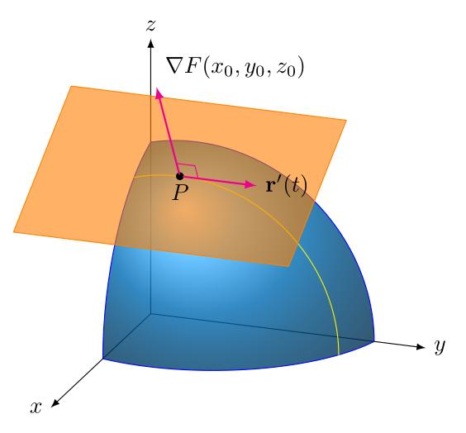
This type can occur when the contact between the plane and a solid follows a curved boundary rather than a single point or straight line.
Important: The precise contact geometry depends on the surface. Not every curved solid has a planar tangent contact curve.

Examples According to Solid Type
# Source: AI Source: Provided by: [Data Path: Persons Table -> ID Column: 1, Name_En Column: Motasem Essam] -> From: [ChatGPT] on [7/25/2026]
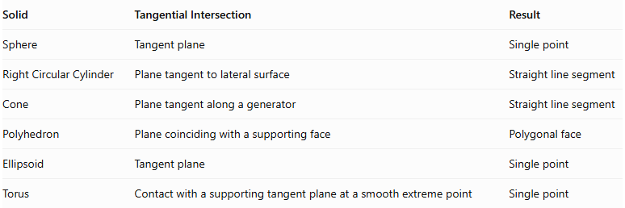
Solid | Tangential Intersection | Result
Sphere | Tangent plane | Single point
Right Circular Cylinder | Plane tangent to lateral surface | Straight line segment
Cone | Plane tangent along a generator | Straight line segment
Polyhedron | Plane coinciding with a supporting face | Polygonal face
Ellipsoid | Tangent plane | Single point
Torus | Contact with a supporting tangent plane at a smooth extreme point | Single point
A polyhedron may also have a supporting plane that touches it along an edge or an entire face.

Mathematical Representation

General Plane Equation
# Source: AI Source: Provided by: [Data Path: Persons Table -> ID Column: 1, Name_En Column: Motasem Essam] -> From: [ChatGPT] on [7/25/2026]
A plane in three-dimensional space is represented by:
$$ax+by+cz+d=0$$
Where:
- $a,b,c$ define the normal vector.
- $d$ determines the plane's position.
The normal vector is:
$$vecn=(a,b,c)$$

Tangent Plane to a Sphere
# Source: AI Source: Provided by: [Data Path: Persons Table -> ID Column: 1, Name_En Column: Motasem Essam] -> From: [ChatGPT] on [7/25/2026]
For a sphere with center $C(h,k,l)$ and radius $R$:
$$(x-h)^{2}+(y-k)^{2}+(z-l)^{2}=R^{2}$$
A tangent plane at the point $P(x_{0},y_{0},z_{0})$ on the sphere is:
$$(x_{0}-h)(x-x_{0})+(y_{0}-k)(y-y_{0})+(z_{0}-l)(z-z_{0})=0$$
The radius from the center to the point of tangency is perpendicular to the tangent plane.

Distance Condition for a Sphere
# Source: AI Source: Provided by: [Data Path: Persons Table -> ID Column: 1, Name_En Column: Motasem Essam] -> From: [ChatGPT] on [7/25/2026]
Let $d$ be the perpendicular distance from the sphere's center to the plane.
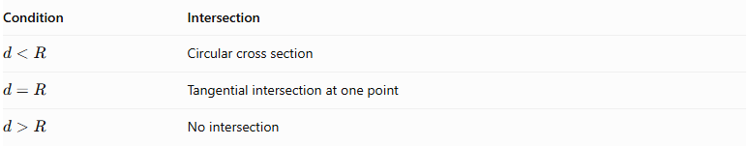
Condition | Intersection
$$d<R$$ | Circular cross section
$$d=R$$ | Tangential intersection at one point
$$d>R$$ | No intersection
The radius of an ordinary circular section is:
$$r=\sqrt{R^{2}-d^{2}}$$
At tangency, $d=R$, so:
$$r=\sqrt{R^{2}-R^{2}}=0$$
Therefore, the circular section reduces to a single point.

Mathematical Properties
# Source: AI Source: Provided by: [Data Path: Persons Table -> ID Column: 1, Name_En Column: Motasem Essam] -> From: [ChatGPT] on [7/25/2026]
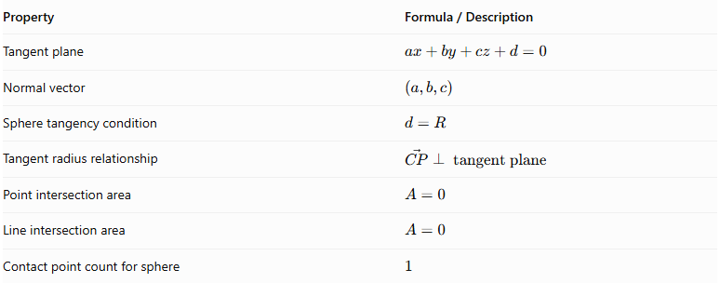
Property | Formula / Description
Tangent plane | $$ax+by+cz+d=0$$
Normal vector | $$(a,b,c)$$
Sphere tangency condition | $$d=R$$
Tangent radius relationship | $$vecCP⊥\text{ tangent plane}$$
Point intersection area | $$A=0$$
Line intersection area | $$A=0$$
Contact point count for sphere | $$1$$

Tangential Cross Section vs. Ordinary Cross Section
# Source: AI Source: Provided by: [Data Path: Persons Table -> ID Column: 1, Name_En Column: Motasem Essam] -> From: [ChatGPT] on [7/25/2026]
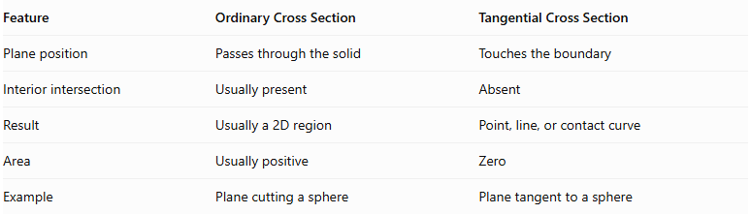
Feature | Ordinary Cross Section | Tangential Cross Section
Plane position | Passes through the solid | Touches the boundary
Interior intersection | Usually present | Absent
Result | Usually a 2D region | Point, line, or contact curve
Area | Usually positive | Zero
Example | Plane cutting a sphere | Plane tangent to a sphere

Main Classification
# Source: AI Source: Provided by: [Data Path: Persons Table -> ID Column: 1, Name_En Column: Motasem Essam] -> From: [ChatGPT] on [7/25/2026]
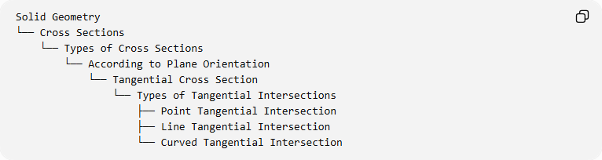
Solid Geometry
└── Cross Sections
└── Types of Cross Sections
└── According to Plane Orientation
└── Tangential Cross Section
└── Types of Tangential Intersections
├── Point Tangential Intersection
├── Line Tangential Intersection
└── Curved Tangential Intersection

Key Points
# Source: AI Source: Provided by: [Data Path: Persons Table -> ID Column: 1, Name_En Column: Motasem Essam] -> From: [ChatGPT] on [7/25/2026]
- A tangential cross section occurs when a plane touches a solid without cutting through its interior.
- A sphere and its tangent plane intersect at exactly one point.
- A cylinder can have a straight line of contact with a tangent plane.
- A polyhedron can be touched along an edge or an entire face.
- A tangential intersection generally has zero two-dimensional area.
- Tangential contact is a limiting case of an ordinary intersection as the cutting plane approaches the boundary.

Conclusion
# Source: AI Source: Provided by: [Data Path: Persons Table -> ID Column: 1, Name_En Column: Motasem Essam] -> From: [ChatGPT] on [7/25/2026]
A Tangential Cross Section describes the limiting contact between a plane and a solid. Unlike ordinary cross sections, which produce two-dimensional regions, tangential intersections can reduce to a point, a straight line, or a curved contact. It is useful for understanding tangent planes, boundary geometry, and the relationship between solids and their supporting planes.

